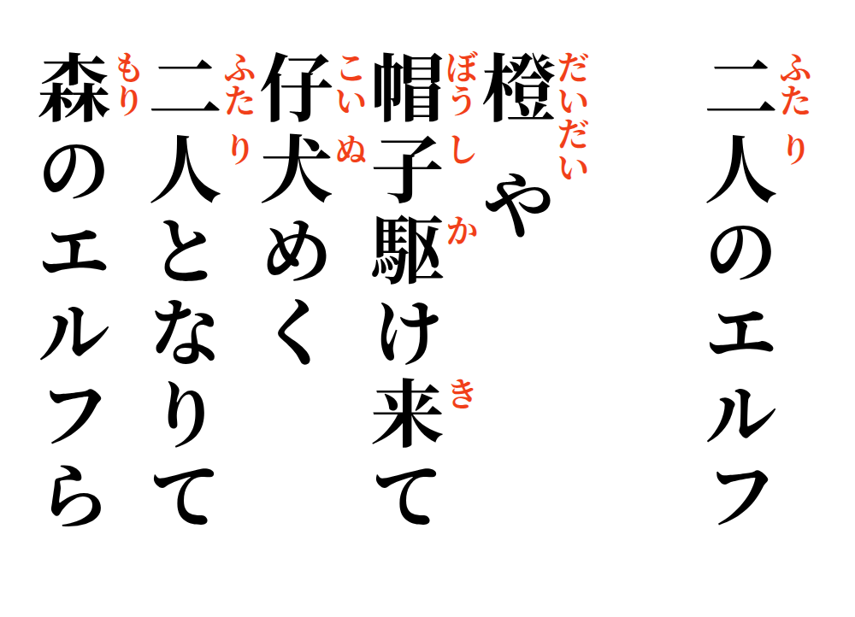

2026-09-25
Two Elf’s
Orange—
the hat comes running toward me,
puppy-like with joy;
then the two become one presence—
the elves of the forest.

